Computer Science

**(Assignment#4)**



**Submitted By:**

**Name: Abdul Rehman Imtiaz**

**Section: BSCS (1C)**

**SAP ID:46885**

**Submitted to: Miss Aliya Farooq.**

**“Programming Fundamental”**

**Riphah School of Computing & Innovation**

**Faculty of Computing**

**Riphah International University, Lahore.**

**Fall 2022.**

**Programme:1**

#include<iostream> using namespace std; struct moviedata

{

string title; string Director;

int year; string time;

};

void displayinfo(moviedata);

int main()

{

moviedata a,b;

a.Director= "hennery";

a.time= "2 hours";

a.title= "Godzilla";

a.year= 2018;

b.Director= "Andrew";

b.time= "2 hours";

b.title= "Avengers";

b.year=2020;

displayinfo(a); displayinfo(b);

}

void displayinfo(moviedata M)

{

cout << "\n\n Move information\n"

<< "-----------------------------------\n"; cout << "Title: " << M.title << endl; cout << "Director: " << M.Director << endl; cout << "Year Released: " << M.year << endl; cout << "Runing Time (minutes): " << M.time << endl;

}

**Output**

**:**

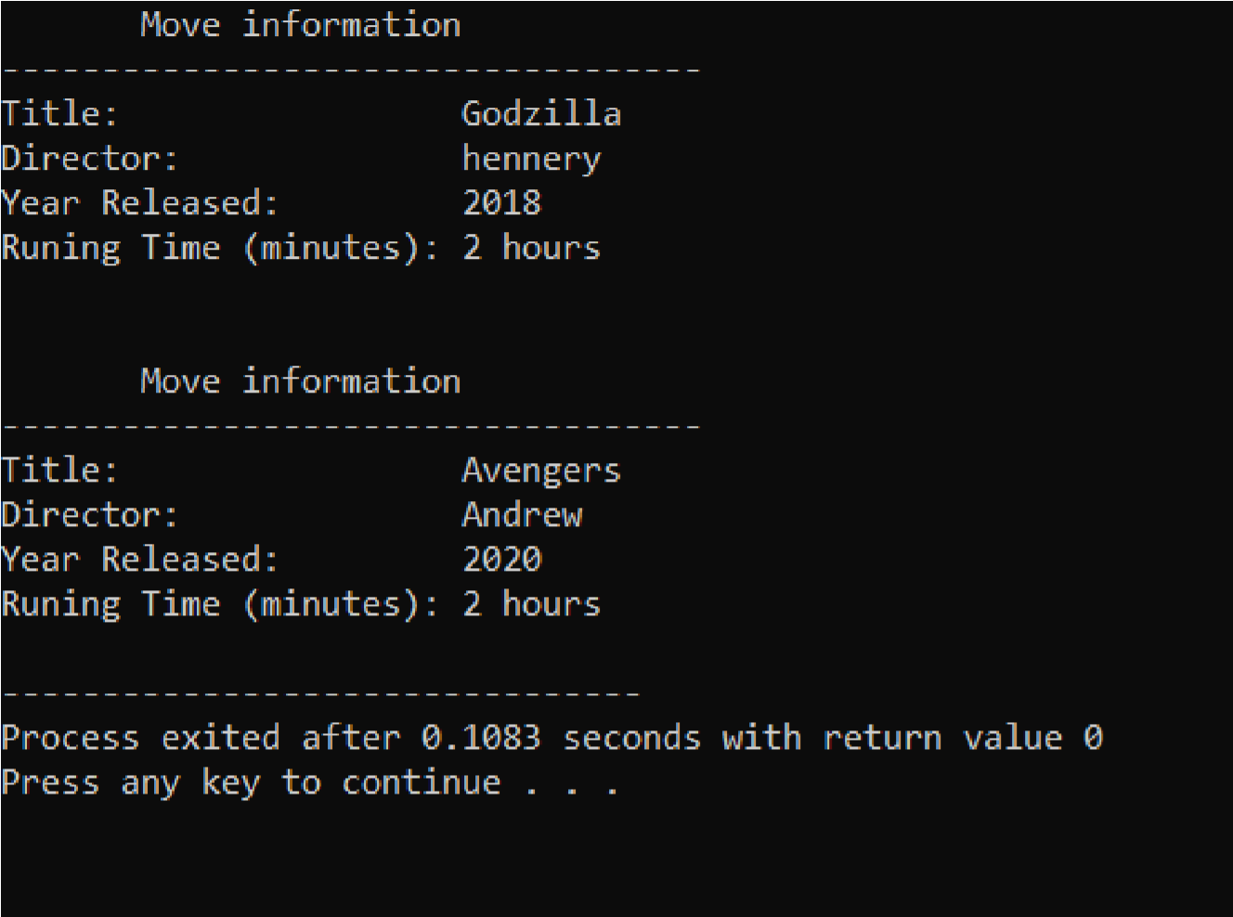

**Programme:2**

#include<iostream> using namespace std; struct moviedata

{

string title; string Director; int year; string time; int production_cost; string first_yr_revenues;

};

void displayinfo(moviedata);

int main()

{

moviedata a,b;

a.Director= "hennery";

a.time= "2 hours";

a.title= "Godzilla";

a.year= 2018;

a.production_cost=100000000;

a.first_yr_revenues="3 million";

b.Director= "Andrew";

b.time= "2 hours";

b.title= "Avengers";

b.year=2020;

b.production_cost=1000000000;

b.first_yr_revenues="4 million";

displayinfo(a); displayinfo(b);

}

void displayinfo(moviedata M)

{

cout << "\n\n Move information\n"

<< "-----------------------------------\n"; cout << "Title: " << M.title << endl; cout << "Director: " << M.Director << endl; cout << "Year Released: " << M.year << endl; cout << "Runing Time (minutes): " << M.time << endl; cout<<"Production Cost: " << M.production_cost<<endl; cout<<"First Year Revenues " << M.first_yr_revenues<<endl;

}

**Output:**

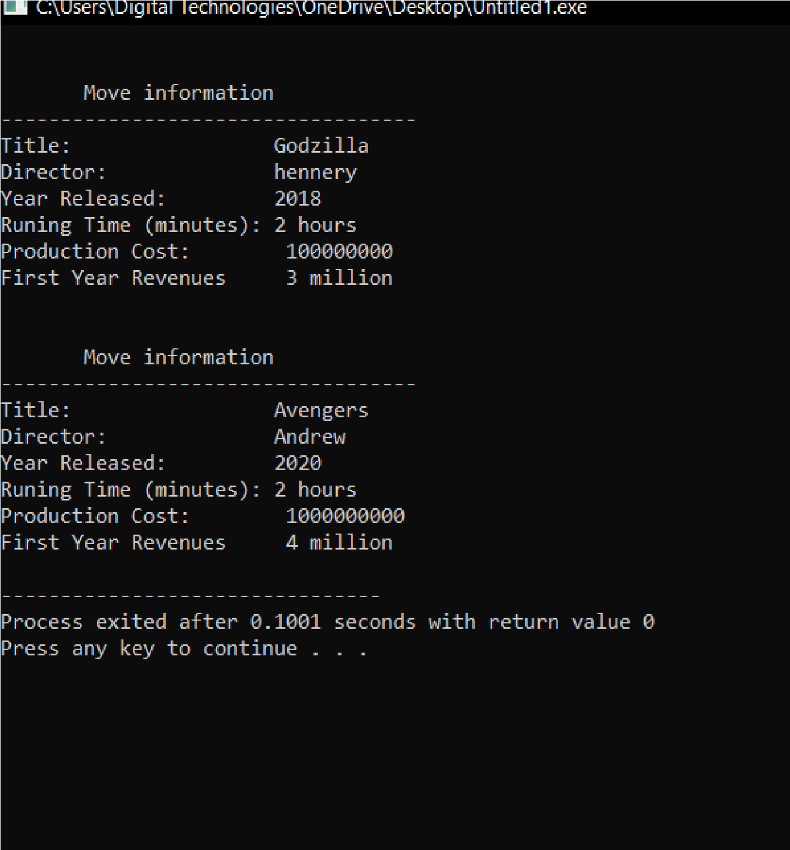

**Programme:3**

#include<iostream> #include<string> using namespace std; struct company

{

string division_name;

int first_quater_sales; int second_quater_sales; int third_quater_sales; int fourth_quater_sales; int total_annuel_sales; int average_quarterly_sales;

};

void calcost(company &); void displayinfo(company); int main()

{

company A,B,C,D;

A.division_name="east";

A.first_quater_sales=1550;

A.second_quater_sales=3100;

A.third_quater_sales=3200;

A.fourth_quater_sales=7300;

B.division_name="west";

B.first_quater_sales=1100;

B.second_quater_sales=4100;

B.third_quater_sales=1300;

B.fourth_quater_sales=1300;

C.division_name="north";

C.first_quater_sales=1400;

C.second_quater_sales=9100;

C.third_quater_sales=1800;

C.fourth_quater_sales=7300;

D.division_name="south";

D.first_quater_sales=1600;

D.second_quater_sales=3100;

D.third_quater_sales=1200;

D.fourth_quater_sales=5300;

calcost(A); calcost(B); calcost(C); calcost(D);

displayinfo(A); displayinfo(B); displayinfo(C); displayinfo(D); return 0;

}

void calcost(company &M)

{

M.total_annuel_sales=M.first_quater_sales+M.second_quater_sales+M.thi rd_quater_sales+M.fourth_quater_sales;

M.average_quarterly_sales=M.total_annuel_sales/4;

}

void displayinfo(company D)

{

cout << "\n Sales Data\n"; cout << "---------------------------------------\n"; //cout << fixed << showpoint << setprecision(2); cout << "Division : " << D.division_name << endl; cout << "Total Sales : $" << D.total_annuel_sales << endl; cout << "Quarterly average : $" << D.average_quarterly_sales << endl;

}

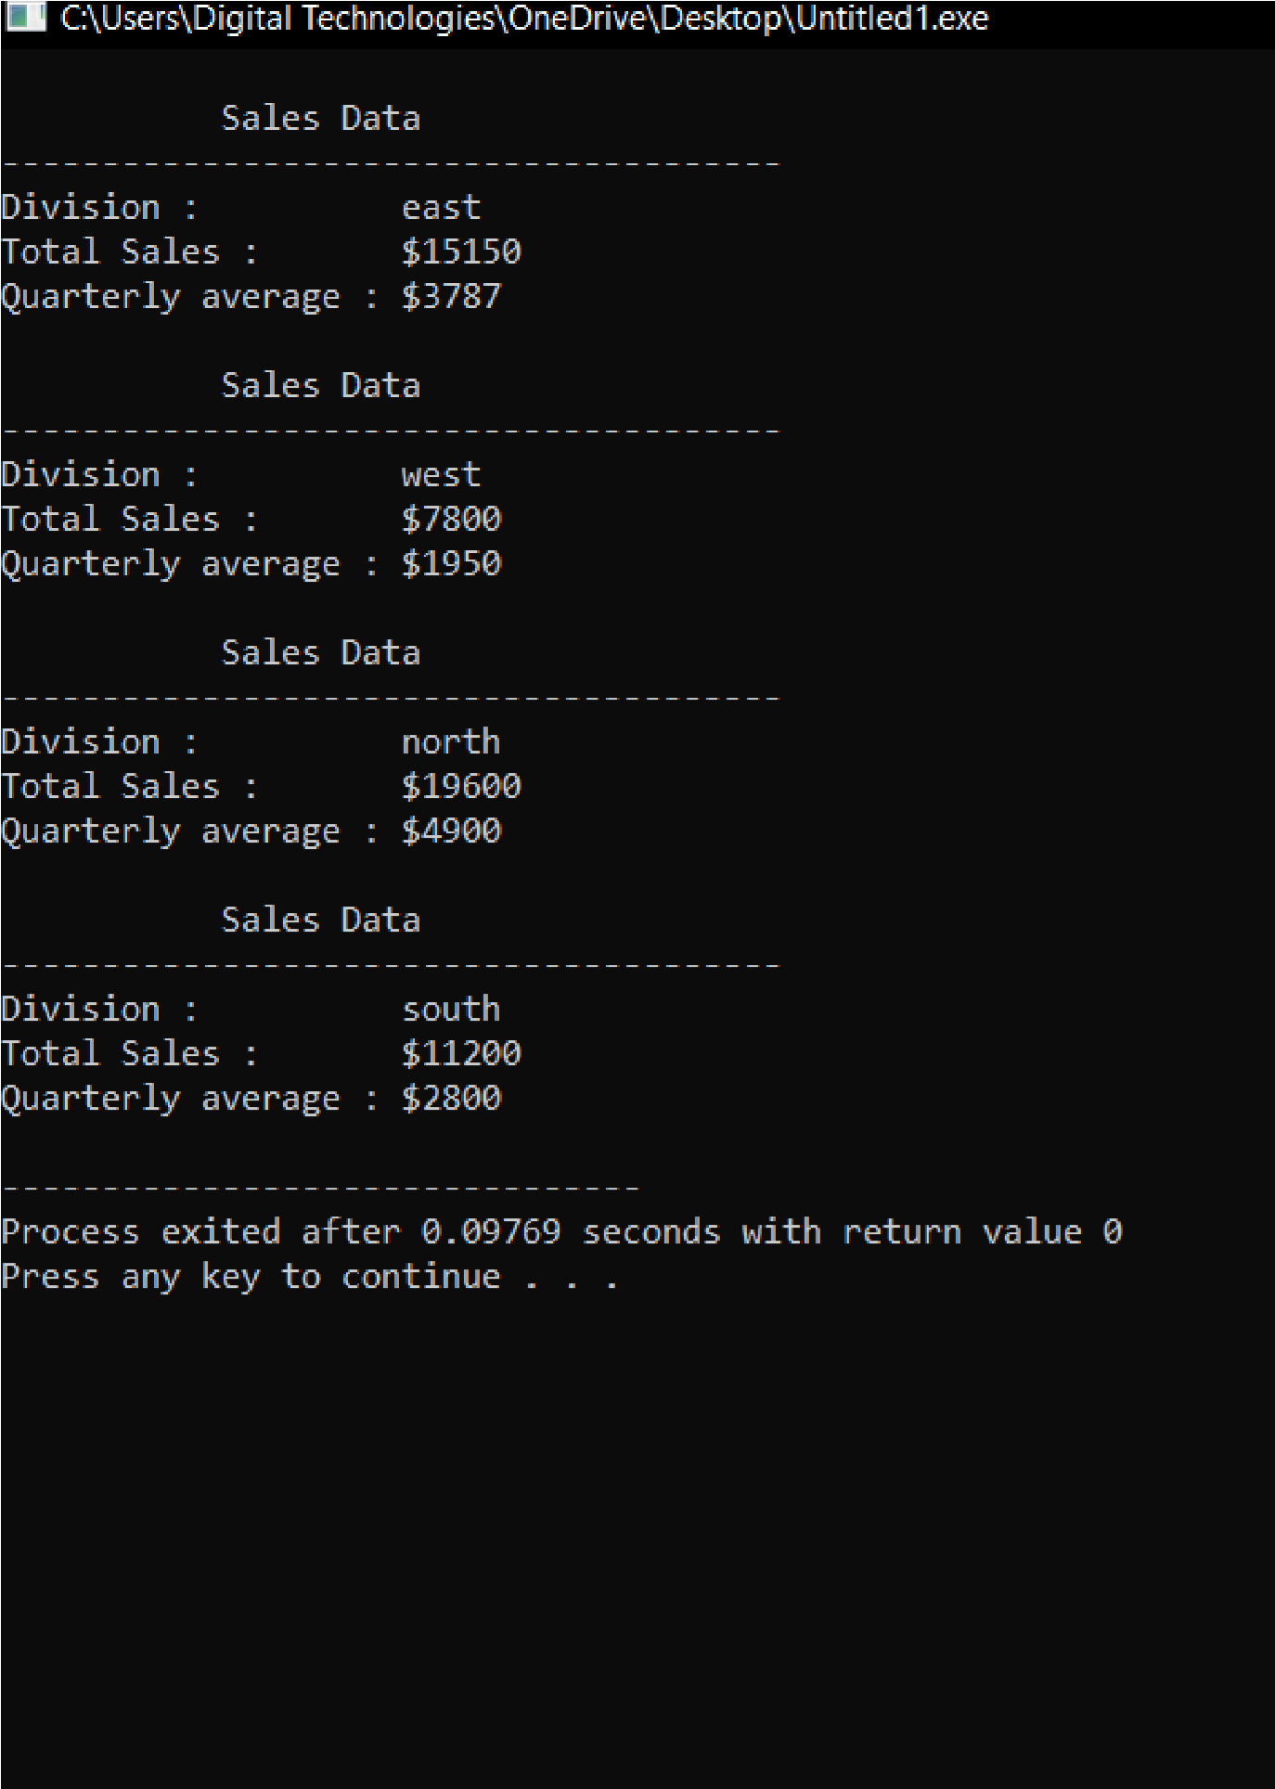

# Programme:4

#include<iostream> using namespace std; const short months = 12;

char MONTHS[months][10] = { "January", "February", "March", "April", "May", "June", "July", "August", "September", "October",

"November", "December" } ; struct Weather_data

{

float total_rainfall; float high_temp; float low_temp; float avg_temp; string month;

};

void setAverage(Weather_data [], int); double arrayAverage(Weather_data [], string); void max_min_temp(Weather_data [], short&, short&); void getData(Weather_data []); void lastBits(Weather_data []); int main()

{

Weather_data array[months];

getData(array);

lastBits(array);

return 0;

}

void setAverage(Weather_data array[],int i )

{

array[i].avg_temp=(array[i].high_temp+array[i].low_temp)/2;

}

double arrayAverage(Weather_data array [], string choice)

{

double average = 0; if(choice == "temp")

{

for(int i = 0; i < months; i++) average += array[i].avg_temp;

return (average / months);

}

if(choice == "rain")

{

for(int i = 0; i < months; i++)

average += array[i].total_rainfall;

return (average / months);

}

}

void max_min_temp(Weather_data array [], short & max_pos, short & min_pos)

{

double min = array[0].low_temp, max = array[0].high_temp; min_pos = 0; max_pos = 0;

for(int i = 1; i < months; i++)

{

if(min > array[i].low_temp)

{

min = array[i].low_temp; min_pos = i;

}

if(max < array[i].high_temp)

{

max = array[i].high_temp; max_pos = i;

}

}

}

void getData(Weather_data array[])

{

cout << "Let's do some weather statistics. " << endl;

cout << "We'll do the total rainfall plus "<< endl; cout << "highest and lowest temperatures" << endl;

cout << "according to months ranging from -100 to 140 degrees "<< endl; cout << "Fahrenheit." << endl;

for(int i = 0; i < months; i++)

{

cout << "From " << MONTHS[i] << ": " << endl;

cout << "Total rainfall: \t";

cin >> array[i].total_rainfall;

while(array[i].total_rainfall < 0)

{

cout << endl << "Please enter something that isn't negative. ";

cout << "Total rainfall: \t";

cin >> array[i].total_rainfall;

}

cout << "Highest temperature: \t";

cin >> array[i].high_temp;

while((array[i].high_temp < -100) or (array[i].high_temp > 140))

{

cout << endl << "Input a temperature " << endl << "ranging from -100 to 140 degrees Fahrenheit. "<< endl;

cout << "Highest temperature: \t";

cin >> array[i].high_temp;

}

cout << "Lowest temperature: \t";

cin >> array[i].low_temp;

while((array[i].low_temp < -100) or (array[i].low_temp > 140) or (array[i].low_temp > array[i].high_temp))

{

cout << "Either you need to input a temperature " << endl <<

"ranging from -100 to 140 degrees " << endl << "Fahrenheit or your lowest is bigger than the highest. " << endl;

cout << "Lowest temperature: \t";

cin >> array[i].low_temp;

}

setAverage(array, i);

cout << endl;

}

}

void lastBits(Weather_data array[])

{

short max_pos, min_pos;

max_min_temp(array, max_pos, min_pos);

cout << "Now to show the last bits of the year. " << endl;

cout << "Average rainfall: \t " << arrayAverage(array, "rain") << endl

<< "Highest temperature: \t " << array[max_pos].high_temp << " (on

" << MONTHS[max_pos] << ")" << endl;

cout<< "Lowest temperature: \t " << array[min_pos].low_temp << " (on " << MONTHS[min_pos] << ")" << endl << "Average temperature: \t " << arrayAverage(array, "temp") << endl;

}

**Output:**

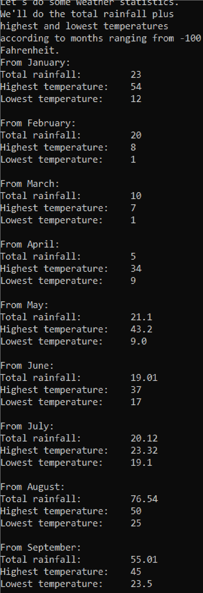

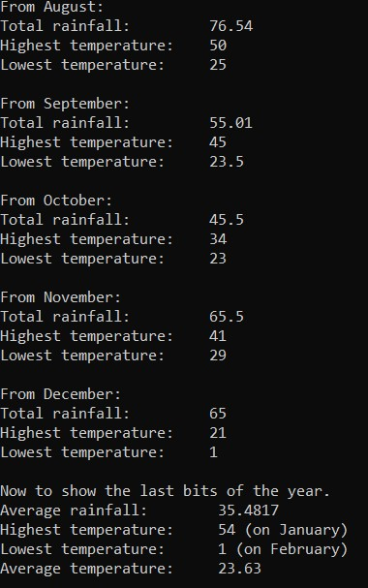

**Programme:5**

#include<iostream>

using namespace std;

struct weather

{

double total_rain_fall;

double hight_t,low_t;

double avg;

};

enum;

months{January=1,February, March, April, May,

June, July, August, September, October,

November, December;

int main ()

{

weather detail[12];

months month_name;

double total=0;

double highest_temperature,lowest_temperature;

string hottest_month,coldest_month;

for(int month_names=January;month_names!=December+1;month_names++)

{

cout<<"enter total amount of rainfall in"<<month_names<<"=";

cin>>detail[month_names].total_rain_fall;

total+=detail[month_names].total_rain_fall;

cout<<"enter highest temperature in"<<month_names<<"=";

cin>>detail[month_names].high_t;

while(detail[month_names].high_t<-100 || detail[month_names].high_t>140)

{

cout<<"invalid input entered"<<endl;

cout<<"enter highest temperature in"<<month_names<<"=";

cin>>detail[month_names].hight_t;

}

cout<<"enter lowest temperature in"<<month_names<<"=";

cin>>detail[month_names].low_t;

while(detail[month_names].low_t<-100 || detail[month_names].low_t>140)

{

cout<<"invalid input entered"<<endl;

cout<<"enter lowest temperature in"<<month_names<<"=";

cin>>detail[month_names].low_t;

}

cout <<"________________________"<<endl;

if(highest_temperature<detail[month_names].hight_t)

{

highest_temperature=detail[month_names].hight_t;

hottest_month=hottest_name;

}

if(lowest_temperature>detail[month_names].low_t)

{

lowest_temperature=detail[month_names].low_t;

coldest_month=hottest_name;

}

}

cout<<"total rain fall in a year:"<<total<<endl;

cout<<"avg rainfall in a year:"<<total/12<<endl;

cout<<"highest temperature:"<<highest_temperature<<" \nrecorded in "<< hottest_month <<endl;

cout<<"lowest temperature:"<<lowest_temperature<<" \nrecorded in "<< coldest_month <<endl;

for(int month_names=January;month_names!=December+1;month_names++)

{

cout<< "average temperature in "<<month_names<<"="<<(detail[month_names].hight_t+detail[month_names].low_t)/2<<endl;

}

}

}

**Output**

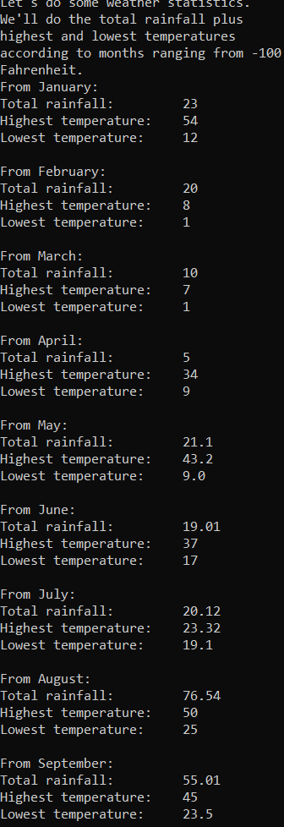

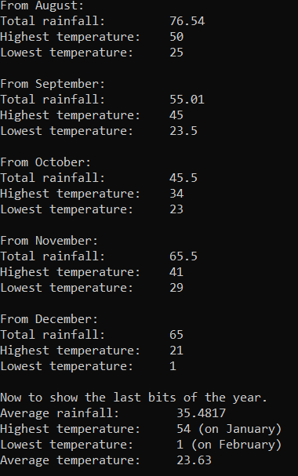

**Programme:6**

#include<iostream> using namespace std; struct players

{

string Name="";

int Number=0; int Scored_by_Player=0; };

void input_info(players arr[], int i); void diplay_info(players arr[], int j); void cal_score(players arr[], int j); int main()

{

players arr[12]; input_info(arr,12); diplay_info(arr,12); cal_score(arr, 12);

}

void input_info(players arr[],int j)

{

for (int i = 0; i < j; i++)

{

cout << "Enter the name of the player " << i + 1 << ":"; cin >> arr[i].Name;

cout << "enter the number of the player " << i + 1 << ":"; cin >> arr[i].Number;

cout << "Enter the score made by the player " << i + 1 << ":"; cin >> arr[i].Scored_by_Player;

cout << "---------------------------------------------------------------------------------" << endl;

}

}

void diplay_info(players arr[],int j)

{

for (int i = 0; i < j; i++)

{

cout << "--------------------------------------------------------------------------------

--" << endl;

cout << " INFORMATION OF THE PLAYERS

" << endl;

cout << "--------------------------------------------------------------------------------

--" << endl;

cout << "NAME OF THE PLAYER " << i + 1 << ":" << arr[i].Name << endl;

cout << "NUMBER OF THE PLAYER " << i + 1 << ":" << arr[i].Number

<< endl;

cout << "SCORE OF THE PLAYER " << i + 1 << ":" << arr[i].Scored_by_Player << endl;

}

}

void cal_score(players arr[], int j)

{

int sum = 0;

for (int i = 0; i < j; i++)

{

sum= sum + arr[i].Scored_by_Player;

}

cout << "----------------------------------------------------------------------------------" << endl;

cout << "TOTAL SCORES OF ALL THE PLYAERS IS:" << sum << endl;

cout << "----------------------------------------------------------------------------------" << endl;

}

**Output**:

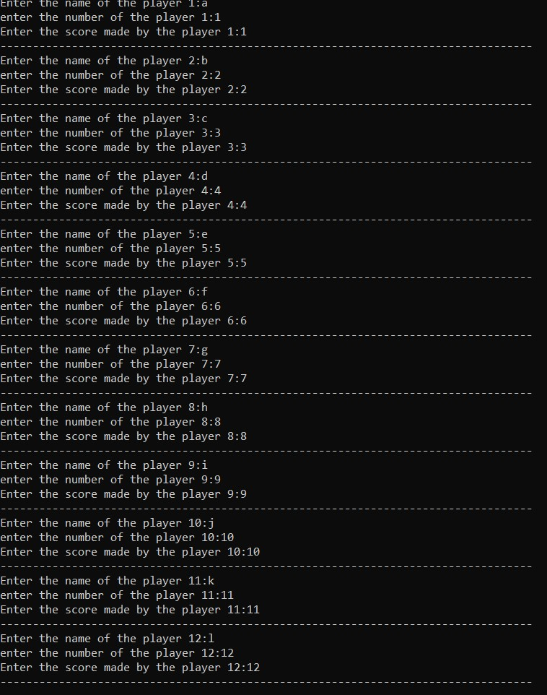

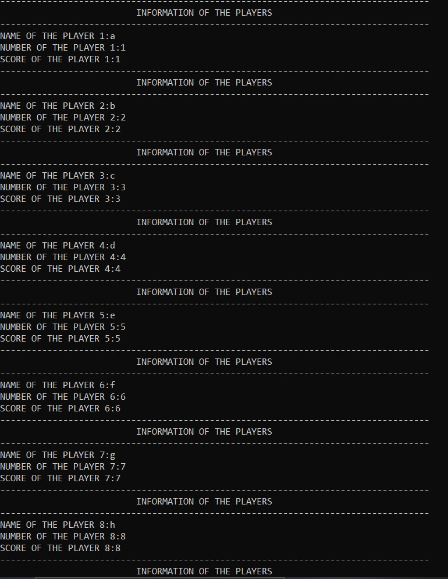

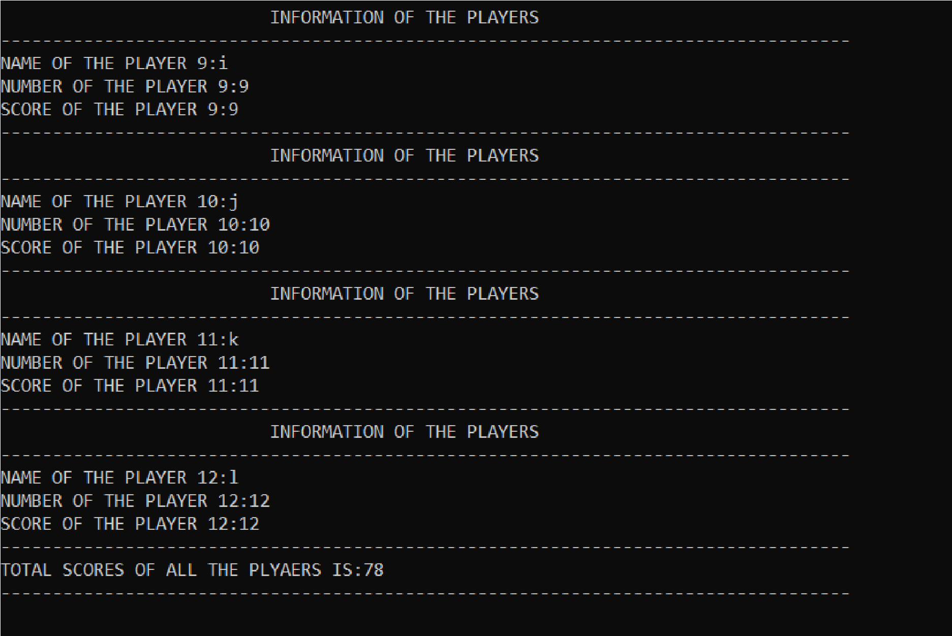

# Programme: 7

#include<iostream> using namespace std; struct customer

{

string Name; string Address; string City, State;

int ZIP=0; int Tel_Num=0;

float Account_Balance=0;

string Date_of_Last_Payment;

};

void input_info(customer arr[], int j); void display_info(customer arr[], int j); void edit_info(customer arr[], int j, string name); int main()

{

int op;

customer x[20]; menu:

cout << "------------------------------------------------------------------------

-" << endl;

cout << " MENU " << endl; cout << "------------------------------------------------------------------------

-" << endl;

cout << "Enter 1 to input the data of the customer" << endl; cout << "Enter 2 to edit data of the customer" << endl; cout << "Enter 3 to display the data of customer " << endl;

cin >> op;

cout << "------------------------------------------------------------------------

-" << endl;

if (op == 1)

{

input_info(x, 20); int back;

cout << " Enter 0 to go back to the menu:";

cin >> back; if (back == 0)

{

goto menu;

}

}

if (op == 2)

{

string a;

cout << "Enter any name of the customer:";

cin >> a;

edit_info(x, 20, a);

int back;

cout << " Enter 0 to go back to the menu:";

cin >> back; if (back == 0)

{

goto menu;

}

}

if (op == 3)

{

display_info(x, 20);

int back;

cout << " Enter 0 to go back to the menu:";

cin >> back; if (back == 0)

{

goto menu;

}

}

}

void input_info(customer arr[], int j)

{

|  |  |
| --- | --- |
|  | for (int i = 0; i < j; i++) |
|  | { |
|  | cout << "Enter the name of the customer " << i + 1 << ":"; |
|  | cin >> arr[i].Name; |
|  | cout << "Enter the address of the customer " << i + 1 << ":"; |
|  | cin >> arr[i].Address; |
| << i + 1 << ":"; | cout << "Enter the name of city in which the customer lives " |
|  | cin >> arr[i].City; |
| << i + 1 << ":"; | cout << "Enter the name of state in which the customer lives " |
|  | cin >> arr[i].State; |
|  | cout << "Enter the ZIP code " << i + 1 << ":"; |
|  | cin >> arr[i].ZIP; |

cout << "Enter the Telephone number of the customer " << i +

1 << ":";

cin >> arr[i].Tel_Num;

cout << "Enter the account balance of the customer " << i + 1

<< ":";

cin >> arr[i].Account_Balance;

cout << "Enter the date of last payment of the customer " << i

+ 1 << ":";

cin >> arr[i].Date_of_Last_Payment;

cout << "------------------------------------------------------------------------" << endl;

}

}

void edit_info(customer arr[],int j, string name)

{

for (int i = 0; i < j; i++)

{

if (arr[i].Name == name)

{

cout << "Enter the address of the customer:"; cin >> arr[i].Address;

cout << "Enter the name of city in which the customer lives:";

cin >> arr[i].City;

cout << "Enter the name of state in which the customer lives:";

cin >> arr[i].State;

cout << "Enter the ZIP code:"; cin >> arr[i].ZIP;

cout << "Enter the Telephone number of the customer:"; cin >> arr[i].Tel_Num;

cout << "Enter the account balance of the customer:"; cin >> arr[i].Account_Balance; cout << "Enter the date of last payment of the customer:";

cin >> arr[i].Date_of_Last_Payment;

}

}

}

void display_info(customer arr[], int j)

{

for (int i = 0; i < j; i++)

{

cout << "------------------------------------------------------------------------

-" << endl;

cout << " INFORMATION OF " << i + 1 <<" CUSTOMER

"<< endl;

cout << "------------------------------------------------------------------------

-" << endl;

cout << "NAME:" << arr[i].Name << endl; cout << "ADSRESS:" << arr[i].Address << endl; cout << "CITY:" << arr[i].City << endl;

cout << "STATE:" << arr[i].State << endl;

cout << "ZIP CODE" << arr[i].ZIP << endl; cout << "TELEPHONE NUMBER:" << arr[i].Tel_Num << endl; cout << "ACCOUNT BALANCE:" << arr[i].Account_Balance << endl;

cout << "DATE OF LAST PAYMENT:" <<

arr[i].Date_of_Last_Payment << endl;

}

}

**Output:**

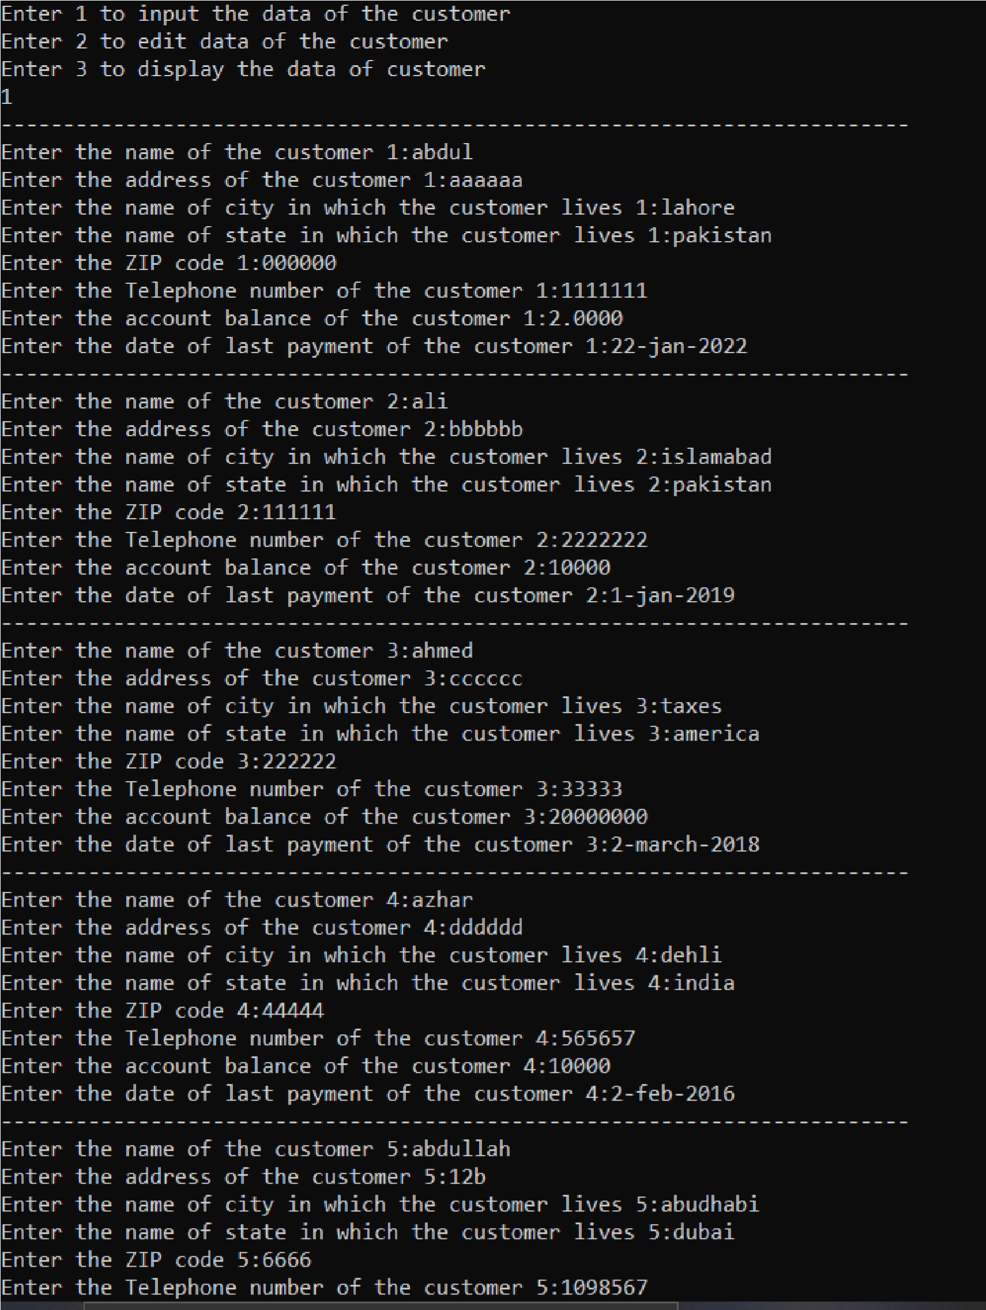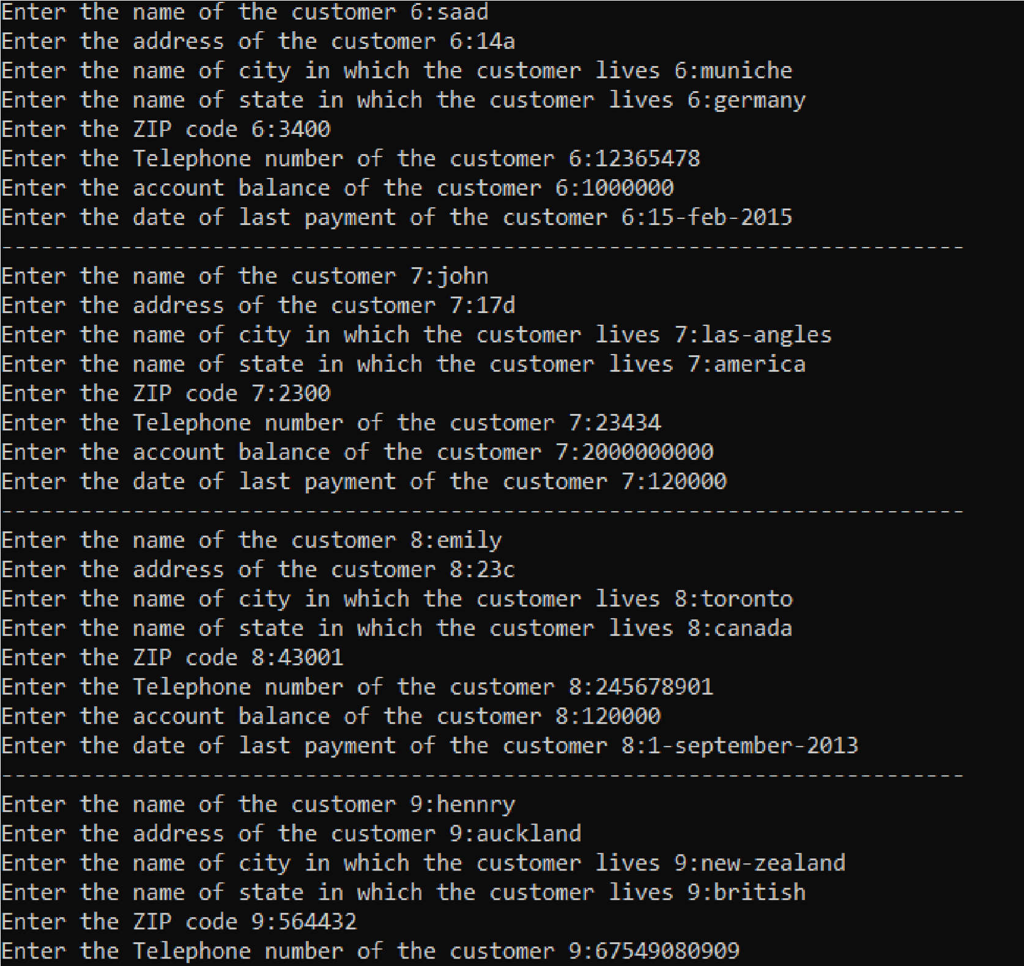

**Programme:8**

#include<iostream> using namespace std; struct customer

{

string Name; string Address; string City, State; int ZIP=0; int Tel_Num=0; float Account_Balance=0;

string Date_of_Last_Payment;

};

void input_info(customer arr[], int j); void display_info(customer arr[], int j); void edit_info(customer arr[], int j, string name); void display_updated_info(customer arr[], int j); void search_info(customer arr[], int j, string name); int main()

{

int op;

customer x[2]; menu:

cout << "------------------------------------------------------------------------

-" << endl;

cout << " MENU " << endl; cout << "------------------------------------------------------------------------

-" << endl;

cout << "Enter 1 to input the data of the customer" << endl; cout << "Enter 2 to display data of the customer" << endl; cout << "Enter 3 to edit the data of customer " << endl; cout << "Enter 4 to display updated data of the customer" << endl;

cout << "Enter 5 to search the data of customer " << endl; cin >> op;

cout << "------------------------------------------------------------------------

-" << endl;

if (op == 1)

{

input_info(x, 2); int back;

cout << " Enter 0 to go back to the menu:";

cin >> back; if (back == 0)

{

goto menu;

}

}

if (op == 2)

{

display_info(x, 2);

int back;

cout << " Enter 0 to go back to the menu:";

cin >> back;

if (back == 0)

{

goto menu;

}

}

if (op == 3)

{

string a;

cout << "Enter name of the customer of which you want to updated data: ";

cin >> a;

edit_info(x, 2, a);

int back;

cout << " Enter 0 to go back to the menu:";

cin >> back; if (back == 0)

{

goto menu;

}

}

if (op == 4)

{

display_updated_info(x, 2);

int back;

cout << " Enter 0 to go back to the menu:";

cin >> back;

if (back == 0)

{

goto menu;

}

}

if (op == 5)

{

string a;

cout << "Enter name of the customer by which you want to search: ";

cin >> a;

search_info(x, 2, a);

int back;

cout << " Enter 0 to go back to the menu:";

cin >> back; if (back == 0)

{

goto menu;

}

}

}

void input_info(customer arr[], int j)

{

for (int i = 0; i < j; i++)

{

cout << "Enter the name of the customer " << i + 1 << ":"; cin >> arr[i].Name;

cout << "Enter the address of the customer " << i + 1 << ":";

cin >> arr[i].Address; cout << "Enter the name of city in which the customer lives "

<< i + 1 << ":";

cin >> arr[i].City;

cout << "Enter the name of state in which the customer lives "

<< i + 1 << ":";

cin >> arr[i].State;

cout << "Enter the ZIP code " << i + 1 << ":"; cin >> arr[i].ZIP;

cout << "Enter the Telephone number of the customer " << i +

1 << ":";

cin >> arr[i].Tel_Num;

cout << "Enter the account balance of the customer " << i + 1

<< ":";

cin >> arr[i].Account_Balance;

cout << "Enter the date of last payment of the customer " << i

+ 1 << ":";

cin >> arr[i].Date_of_Last_Payment;

cout << "------------------------------------------------------------------------" << endl;

}

}

void edit_info(customer arr[],int j, string name)

{

for (int i = 0; i < j; i++)

{

if (arr[i].Name == name)

{

|  |  |  |
| --- | --- | --- |
|  |  | cout << "Enter the address of the customer:"; |
|  |  | cin >> arr[i].Address; |
| lives:"; |  | cout << "Enter the name of city in which the customer |
|  |  | cin >> arr[i].City; |
| lives:"; |  | cout << "Enter the name of state in which the customer |
|  |  | cin >> arr[i].State; |
|  |  | cout << "Enter the ZIP code:"; |
|  |  | cin >> arr[i].ZIP; |
|  |  | cout << "Enter the Telephone number of the customer:"; |
|  |  | cin >> arr[i].Tel_Num; |
|  |  | cout << "Enter the account balance of the customer:"; |
|  |  | cin >> arr[i].Account_Balance; |
| customer:"; |  | cout << "Enter the date of last payment of the |
|  |  | cin >> arr[i].Date_of_Last_Payment; |
|  | } |  |
|  | } |  |

}

void display_info(customer arr[], int j)

{

for (int i = 0; i < j; i++)

{

cout << "------------------------------------------------------------------------

-" << endl;

cout << " INFORMATION OF " << i + 1 <<" CUSTOMER

"<< endl;

cout << "------------------------------------------------------------------------

-" << endl;

cout << "NAME:" << arr[i].Name << endl; cout << "ADSRESS:" << arr[i].Address << endl; cout << "CITY:" << arr[i].City << endl; cout << "STATE:" << arr[i].State << endl; cout << "ZIP CODE" << arr[i].ZIP << endl; cout << "TELEPHONE NUMBER:" << arr[i].Tel_Num << endl; cout << "ACCOUNT BALANCE:" << arr[i].Account_Balance << endl;

cout << "DATE OF LAST PAYMENT:" <<

arr[i].Date_of_Last_Payment << endl;

}

}

void display_updated_info(customer arr[], int j)

{

for (int i = 0; i < j; i++)

{

cout << "------------------------------------------------------------------------

-" << endl;

cout << " UPDATED INFORMATION OF " << i + 1 << "

CUSTOMER " << endl;

cout << "------------------------------------------------------------------------

-" << endl;

cout << "NAME:" << arr[i].Name << endl; cout << "ADSRESS:" << arr[i].Address << endl; cout << "CITY:" << arr[i].City << endl; cout << "STATE:" << arr[i].State << endl; cout << "ZIP CODE" << arr[i].ZIP << endl; cout << "TELEPHONE NUMBER:" << arr[i].Tel_Num << endl; cout << "ACCOUNT BALANCE:" << arr[i].Account_Balance << endl;

cout << "DATE OF LAST PAYMENT:" <<

arr[i].Date_of_Last_Payment << endl;

}

}

void search_info(customer arr[],int j, string name)

{

cout << "------------------------------------------------------------------------

-" << endl;

cout << " SEARCHED INFORMATION OF CUSTOMER "

<< endl;

cout << "------------------------------------------------------------------------

-" << endl;

for (int i = 0; i < j; i++)

{

if (name == arr[i].Name)

{

cout << "NAME:" << arr[i].Name << endl; cout << "ADSRESS:" << arr[i].Address << endl; cout << "CITY:" << arr[i].City << endl; cout << "STATE:" << arr[i].State << endl; cout << "ZIP CODE" << arr[i].ZIP << endl;

cout << "TELEPHONE NUMBER:" << arr[i].Tel_Num

<< endl;

cout << "ACCOUNT BALANCE:" << arr[i].Account_Balance << endl;

cout << "DATE OF LAST PAYMENT:" <<

arr[i].Date_of_Last_Payment << endl;

}

else

{

cout << "NO MATCH FOUND" << endl;

}

}

}

**Output:**

**Display the data of program**

**me**

**:**

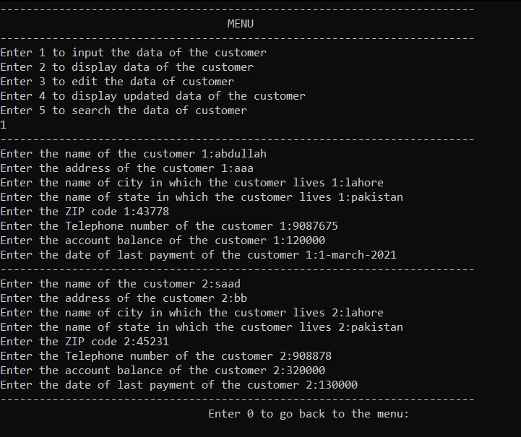

**Updating the data:**

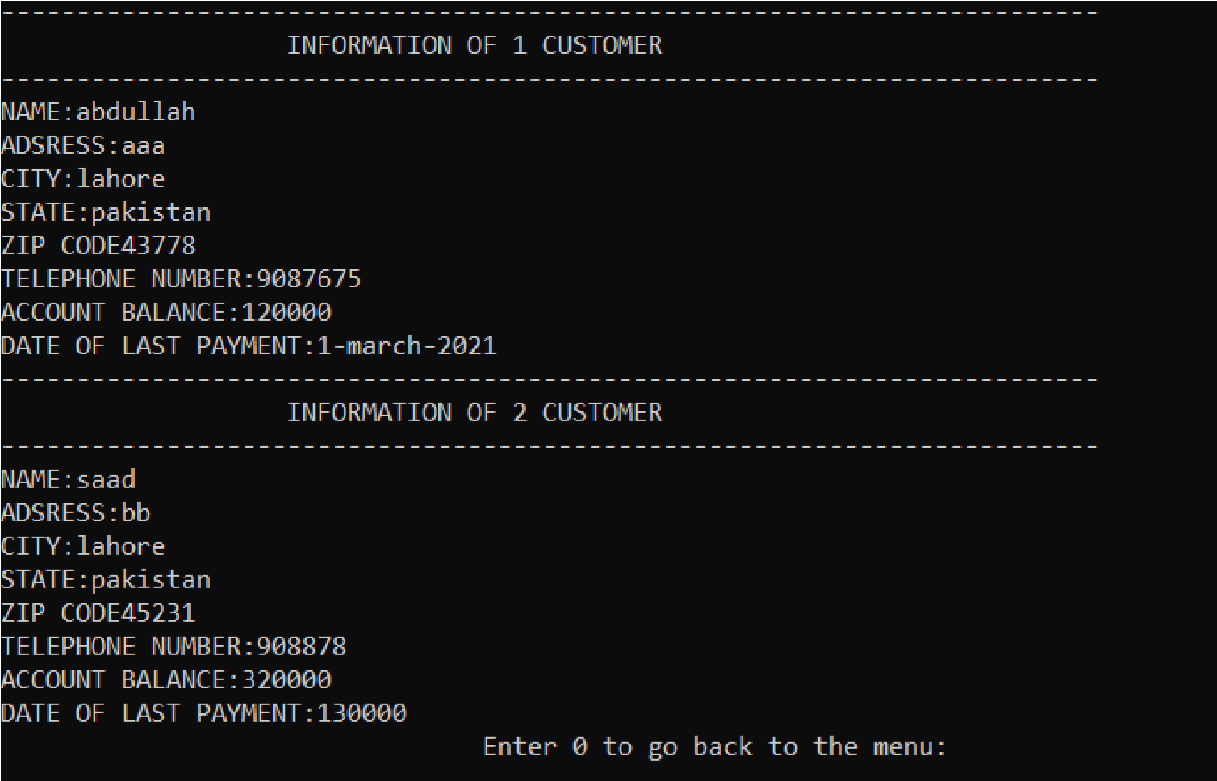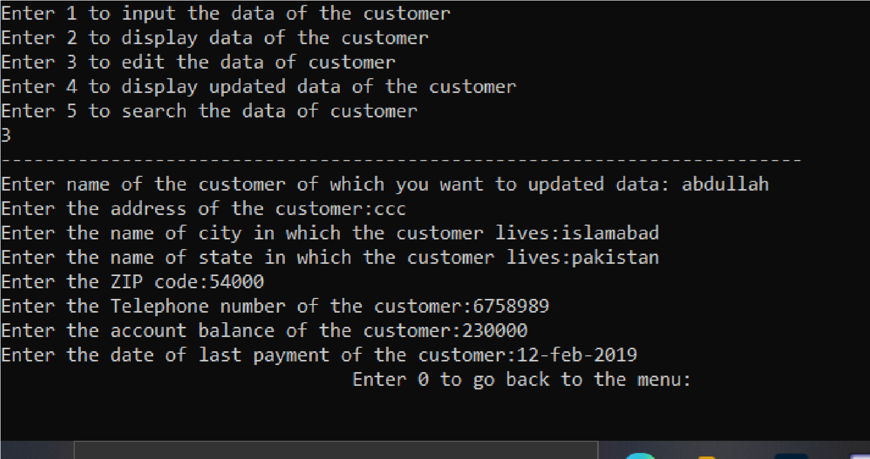

**Displaying the updated data of customer**

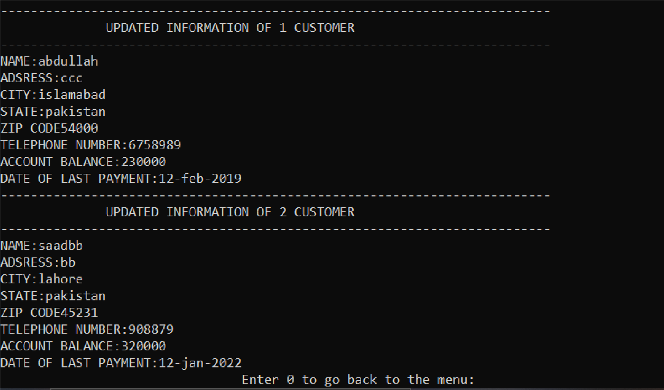

**Searching the customer by name:**

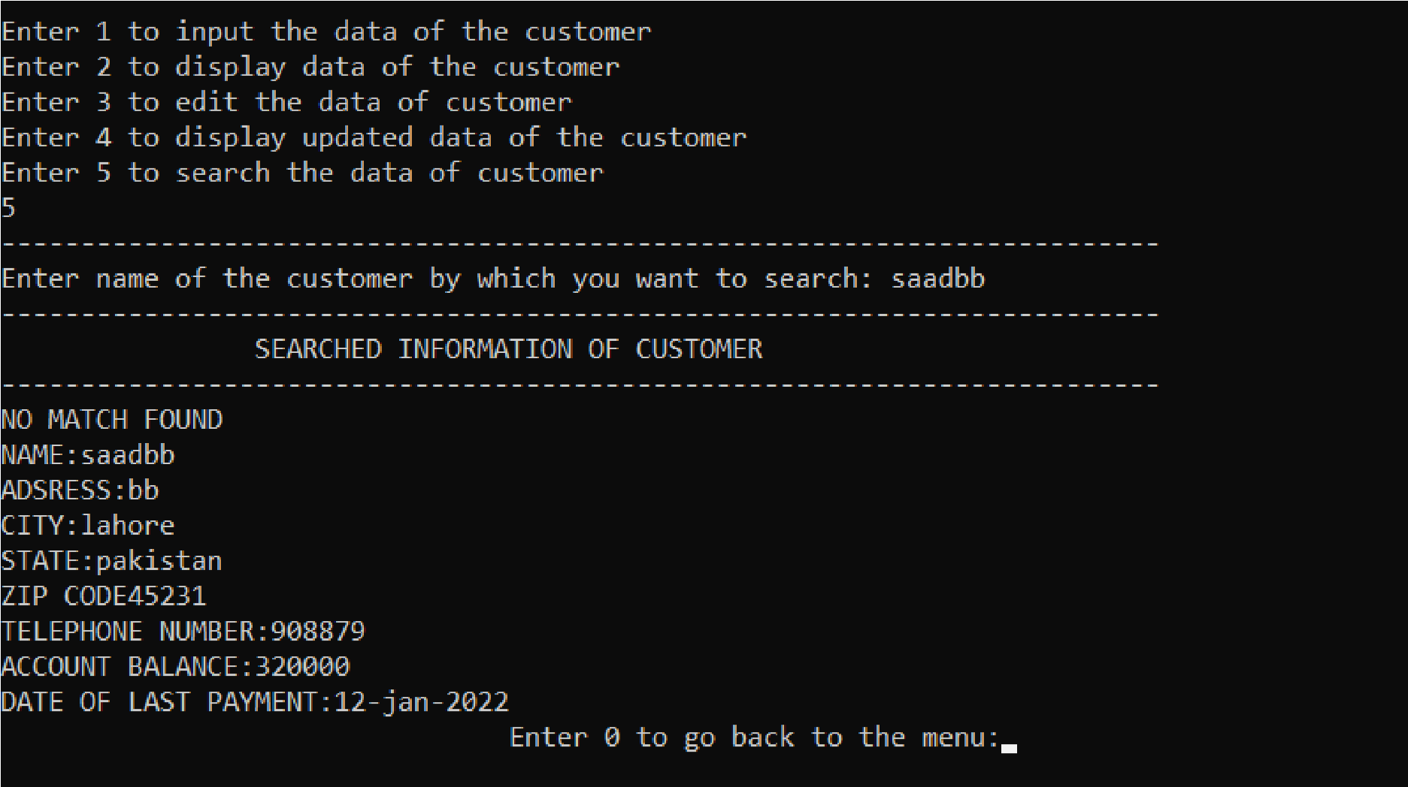

# Programme: 9

#include<iostream> using namespace std; struct speaker

{

string name; string tel_num; string speaking_topic; int fee_requied ;

};

void input_info(speaker arr[], int j); void edit_info(speaker arr[], int j, string n); void display_info(speaker arr[], int j); void display_updated_info(speaker arr[], int j); int main()

{

int op; speaker x[2]; menu:

cout << "------------------------------------------------------------------------

-" << endl;

cout << " MENU " << endl;

cout << "------------------------------------------------------------------------" << endl;

cout << "Enter 1 to input the data of the speaker" << endl; cout << "Enter 2 to display data of the speaker" << endl;

cout << "Enter 3 to edit the data of speaker " << endl; cout << "Enter 4 to display updated data of the speaker" << endl;

cin >> op;

cout << "------------------------------------------------------------------------

-" << endl;

if (op == 1)

{

input_info(x, 2); int back;

cout << " Enter 0 to go back to the menu:";

cin >> back; if (back == 0)

{

goto menu;

}

}

if (op == 2)

{

display_info(x, 2);

int back;

cout << " Enter 0 to go back to the menu:";

cin >> back; if (back == 0)

{

goto menu;

}

}

if (op == 3)

{

string a;

cout << "Enter name of the speaker of which you want to updated data:";

cin >> a;

edit_info(x, 2, a);

int back;

cout << " Enter 0 to go back to the menu:";

cin >> back; if (back == 0)

{

goto menu;

}

}

if (op == 4)

{

display_updated_info(x, 2);

int back;

cout << " Enter 0 to go back to the

menu:";

cin >> back; if (back == 0)

{

goto menu;

}

}

}

void input_info(speaker arr[], int j)

{

for (int i = 0; i < j; i++)

{

cout << "------------------------------------------------------------------------

-" << endl;

cout << " INFORMATION OF " << i + 1 <<" SPEAKER"<< endl;

cout << "------------------------------------------------------------------------

-" << endl;

cout << "Enter the name of the speaker:"; cin >> arr[i].name;

cout << "Enter tha telephone number of the speaker:"; cin >> arr[i].tel_num;

cout << "Enter the topic of the speach:";

cin >> arr[i].speaking_topic;

cout << "Enter the fee requied for the speaker:";

cin >> arr[i].fee_requied;

}

}

void edit_info(speaker arr[], int j,string n)

{

cout << "------------------------------------------------------------------------

-" << endl;

cout << " UPDATE INFORMATION OF SPEAKER" << endl;

cout << "------------------------------------------------------------------------

-" << endl;

for (int i = 0; i < j; i++)

{

if (arr[i].name == n)

{

cout << "Enter tha telephone number of the speaker:"; cin >> arr[i].tel_num;

cout << "Enter the topic of the speach:"; cin >> arr[i].speaking_topic;

cout << "Enter the fee requied for the speaker:"; cin >> arr[i].fee_requied;

}

}

}

void display_info(speaker arr[], int j)

{

for (int i = 0; i < j; i++)

{

cout << "------------------------------------------------------------------------

-" << endl;

cout << " INFORMATION OF " << i + 1 << " SPEAKER"

<< endl;

cout << "------------------------------------------------------------------------

-" << endl;

cout << "NAME:" << arr[i].name << endl; cout << "TELEPHONE NUMBER:" << arr[i].tel_num << endl; cout << "SPEAKING TOPIC:" << arr[i].speaking_topic << endl; cout << "FEE REQUIED:" << arr[i].fee_requied << endl;

}

}

void display_updated_info(speaker arr[], int j)

{

for (int i = 0; i < j; i++)

{

cout << "------------------------------------------------------------------------

-" << endl;

cout << " UPDATED INFORMATION OF " << i + 1 << " SPEAKER" << endl;

cout << "------------------------------------------------------------------------

-" << endl;

cout << "NAME:" << arr[i].name << endl; cout << "TELEPHONE NUMBER:" << arr[i].tel_num << endl; cout << "SPEAKING TOPIC:" << arr[i].speaking_topic << endl; cout << "FEE REQUIED:" << arr[i].fee_requied << endl;

}

}

**Output:**

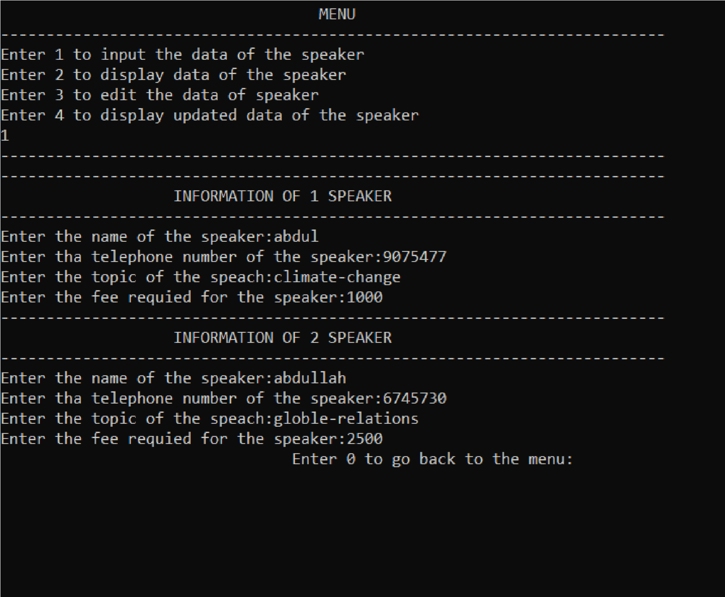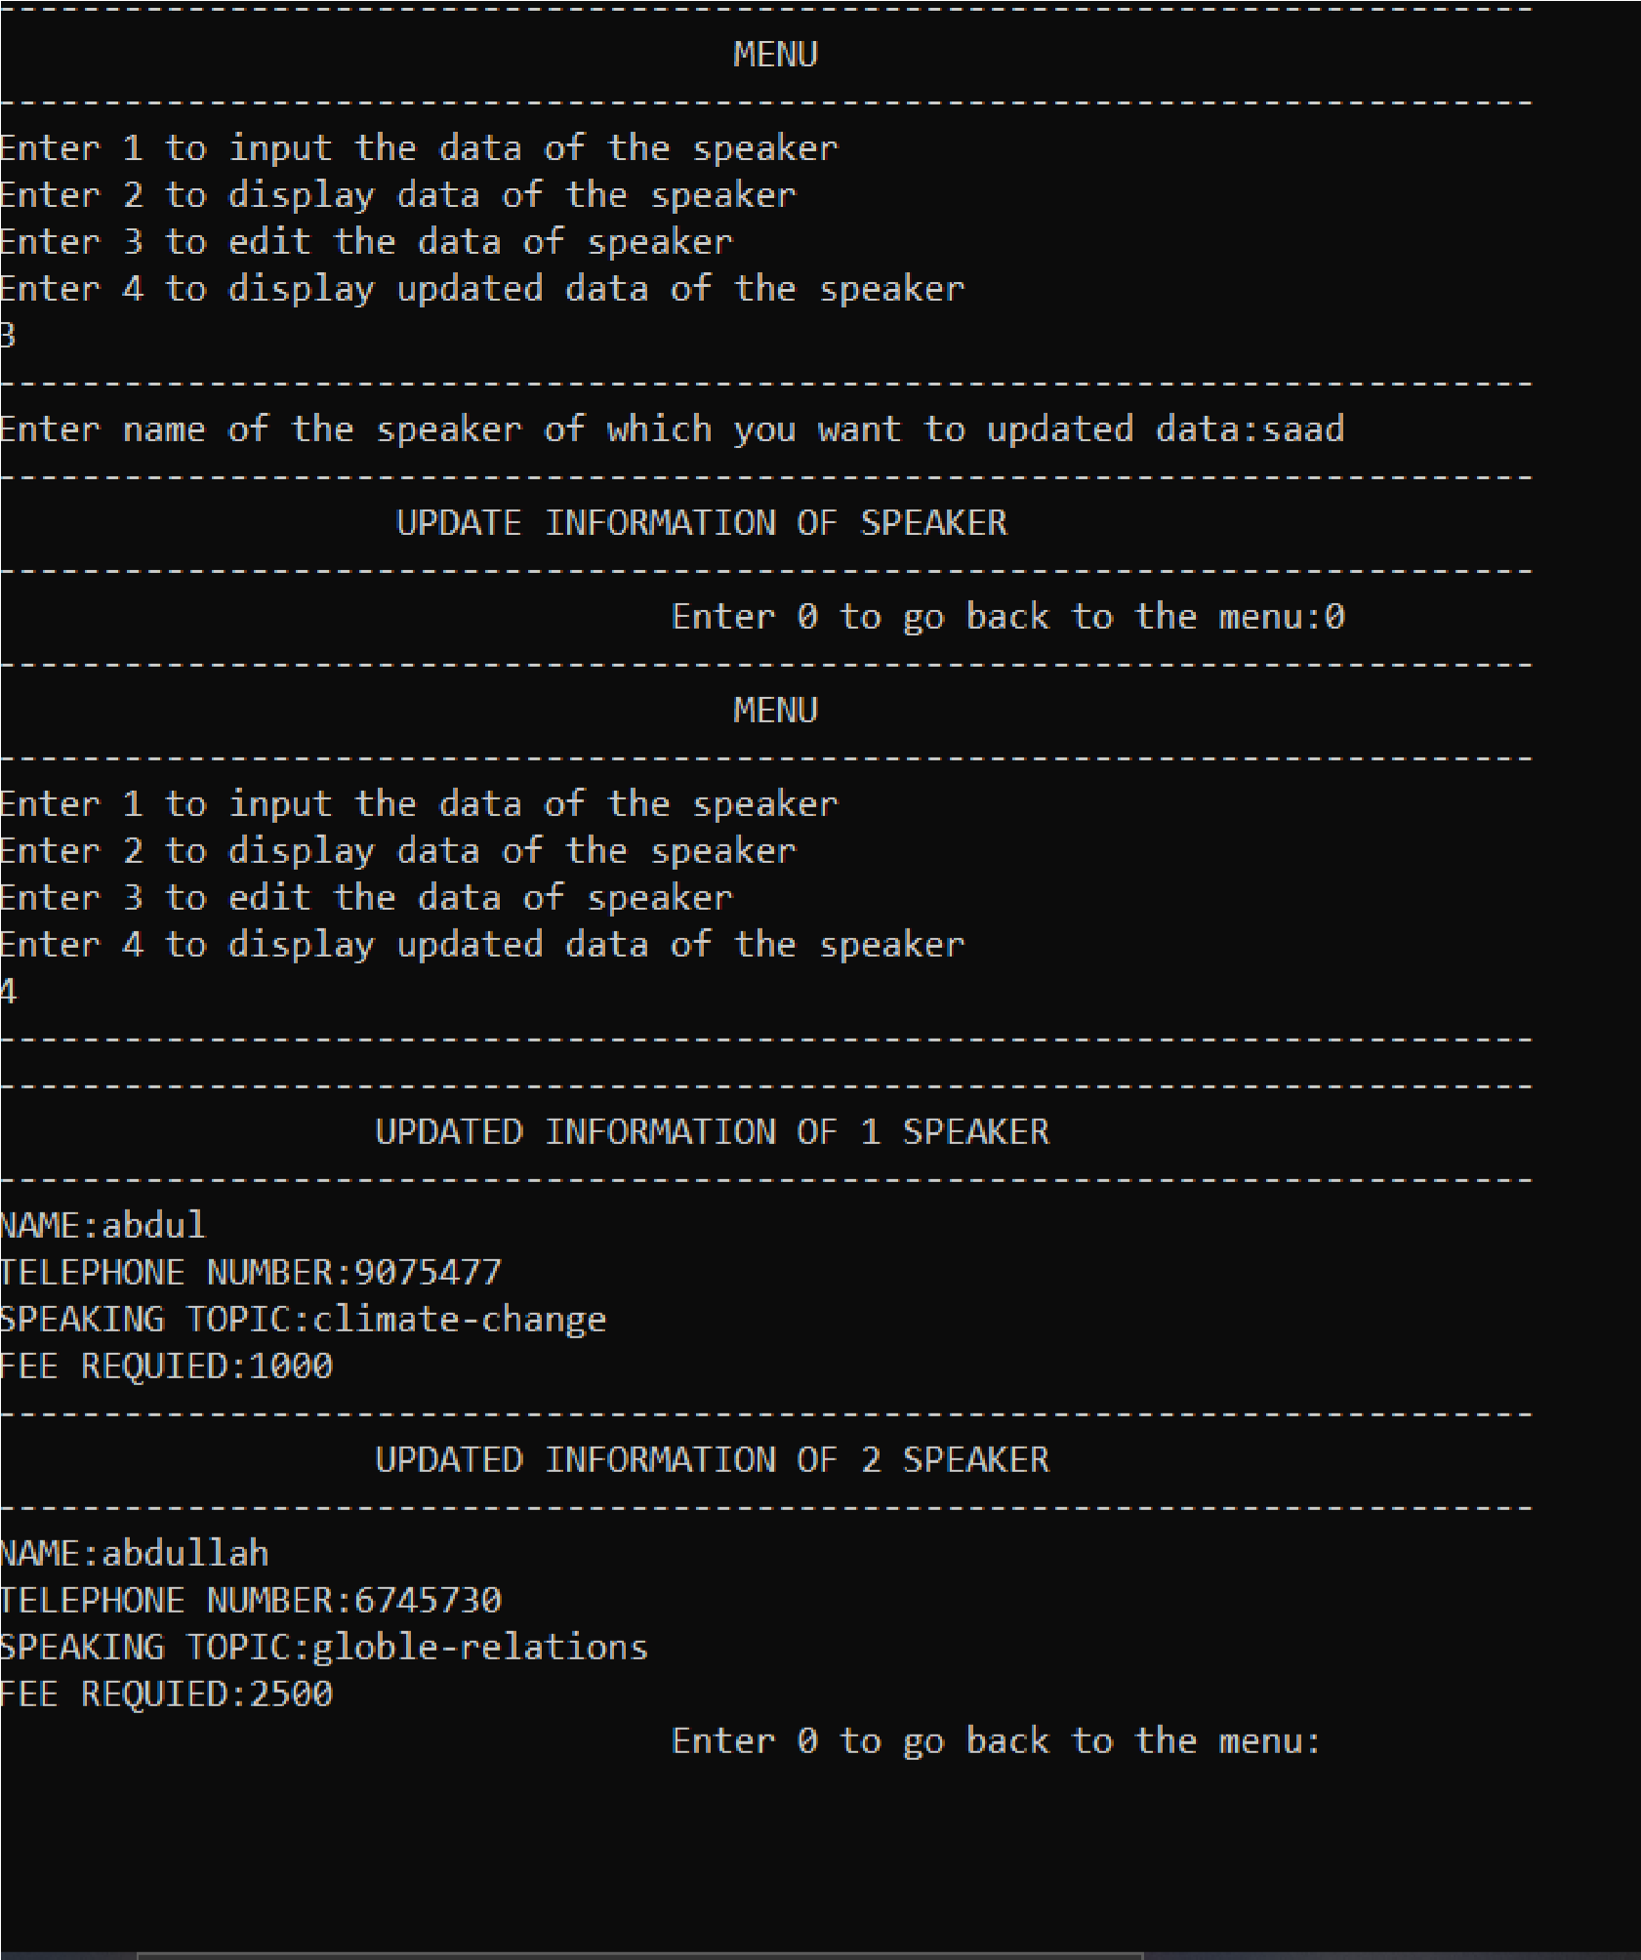

**Programme:10**

#include<iostream> using namespace std; struct speaker

{

string name; string tel_num; string speaking_topic; int fee_requied ;

};

void input_info(speaker arr[], int j); void edit_info(speaker arr[], int j, string n); void display_info(speaker arr[], int j); void display_updated_info(speaker arr[], int j); void search_info(speaker arr[], int j, string name); int main()

{

int op;

speaker x[2]; menu:

cout << "------------------------------------------------------------------------

-" << endl;

cout << " MENU " << endl; cout << "------------------------------------------------------------------------

-" << endl;

cout << "Enter 1 to input the data of the speaker" << endl; cout << "Enter 2 to display data of the speaker" << endl; cout << "Enter 3 to edit the data of speaker " << endl;

cout << "Enter 4 to display updated data of the speaker" <<

endl;

cout << "Enter 5 to search the data of speaker " << endl;

cin >> op;

cout << "------------------------------------------------------------------------

-" << endl;

if (op == 1)

{

input_info(x, 2); int back;

cout << " Enter 0 to go back to the menu:";

cin >> back; if (back == 0)

{

goto menu;

}

}

if (op == 2)

{

display_info(x, 2);

int back;

cout << " Enter 0 to go back to the menu:";

cin >> back; if (back == 0)

{

goto menu;

}

}

if (op == 3)

{

string a;

cout << "Enter name of the speaker you want to edit the data:";

cin >> a;

edit_info(x, 2, a);

int back;

cout << " Enter 0 to go back to the menu:";

cin >> back; if (back == 0)

{

goto menu;

}

}

if (op == 4)

{

display_updated_info(x, 2);

int back;

cout << " Enter 0 to go back to the menu:";

cin >> back; if (back == 0) {

goto menu;

}

}

if (op == 5)

{

string a;

cout << "Enter name of the speaker by which you want to search: ";

cin >> a;

search_info(x, 2, a);

int back;

cout << " Enter 0 to go back to the menu:";

cin >> back; if (back == 0)

{

goto menu;

}

}

}

void input_info(speaker arr[], int j)

{

for (int i = 0; i < j; i++)

{

cout << "------------------------------------------------------------------------

-" << endl;

cout << " INFORMATION OF " << i + 1 << " SPEAKER"

<< endl;

cout << "------------------------------------------------------------------------

-" << endl;

cout << "Enter the name of the speaker:"; cin >> arr[i].name;

cout << "Enter tha telephone number of the speaker:"; cin >> arr[i].tel_num;

cout << "Enter the topic of the speach:"; cin >> arr[i].speaking_topic;

cout << "Enter the fee requied for the speaker:"; cin >> arr[i].fee_requied;

}

}

void edit_info(speaker arr[], int j, string n)

{

cout << "------------------------------------------------------------------------

-" << endl;

cout << " UPDATE INFORMATION OF SPEAKER" << endl;

cout << "------------------------------------------------------------------------

-" << endl;

for (int i = 0; i < j; i++)

{

if (arr[i].name == n)

{

cout << "Enter tha telephone number of the speaker:"; cin >> arr[i].tel_num;

cout << "Enter the topic of the speach:"; cin >> arr[i].speaking_topic;

cout << "Enter the fee requied for the speaker:"; cin >> arr[i].fee_requied;

}

}

}

void display_info(speaker arr[], int j)

{

for (int i = 0; i < j; i++)

{

cout << "------------------------------------------------------------------------

-" << endl;

cout << " INFORMATION OF " << i + 1 << " SPEAKER"

<< endl;

cout << "------------------------------------------------------------------------

-" << endl;

cout << "NAME:" << arr[i].name << endl; cout << "TELEPHONE NUMBER:" << arr[i].tel_num << endl; cout << "SPEAKING TOPIC:" << arr[i].speaking_topic << endl; cout << "FEE REQUIED:" << arr[i].fee_requied << endl;

}

}

void display_updated_info(speaker arr[], int j)

{

for (int i = 0; i < j; i++)

{

cout << "------------------------------------------------------------------------

-" << endl;

cout << " UPDATED INFORMATION OF " << i + 1 << " SPEAKER" << endl;

cout << "------------------------------------------------------------------------

-" << endl;

cout << "NAME:" << arr[i].name << endl; cout << "TELEPHONE NUMBER:" << arr[i].tel_num << endl; cout << "SPEAKING TOPIC:" << arr[i].speaking_topic << endl; cout << "FEE REQUIED:" << arr[i].fee_requied << endl;

}

}

void search_info(speaker arr[], int j, string name)

{

cout << "------------------------------------------------------------------------

-" << endl;

cout << " SEARCHED INFORMATION OF CUSTOMER "

<< endl;

cout << "------------------------------------------------------------------------

-" << endl;

for (int i = 0; i < j; i++) {

|  |  |  |
| --- | --- | --- |
|  | if (name == arr[i].name) | |
|  | { |  |
|  |  | cout << "NAME:" << arr[i].name << endl; |
| endl; |  | cout << "TELEPHONE NUMBER:" << arr[i].tel_num << |
| endl; |  | cout << "SPEAKING TOPIC:" << arr[i].speaking_topic << |
|  |  | cout << "FEE REQUIED:" << arr[i].fee_requied << endl; |
|  | } |  |
|  | } |  |

}

**Output:**

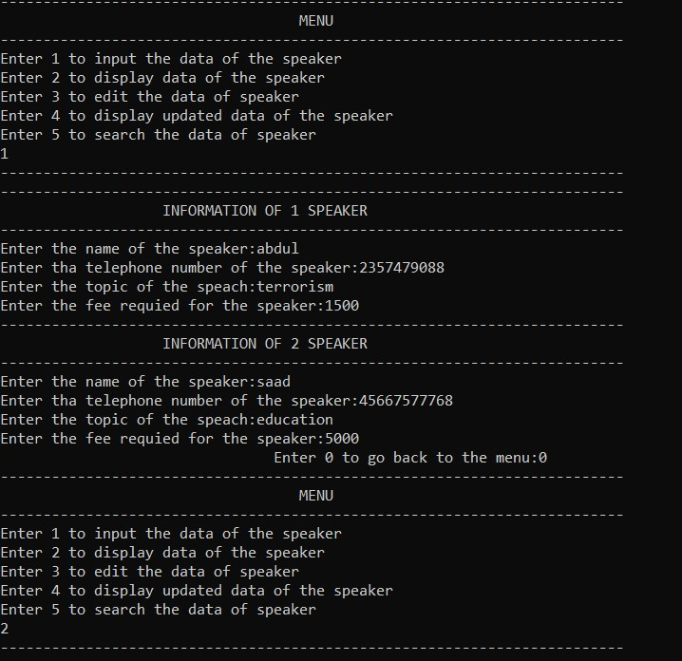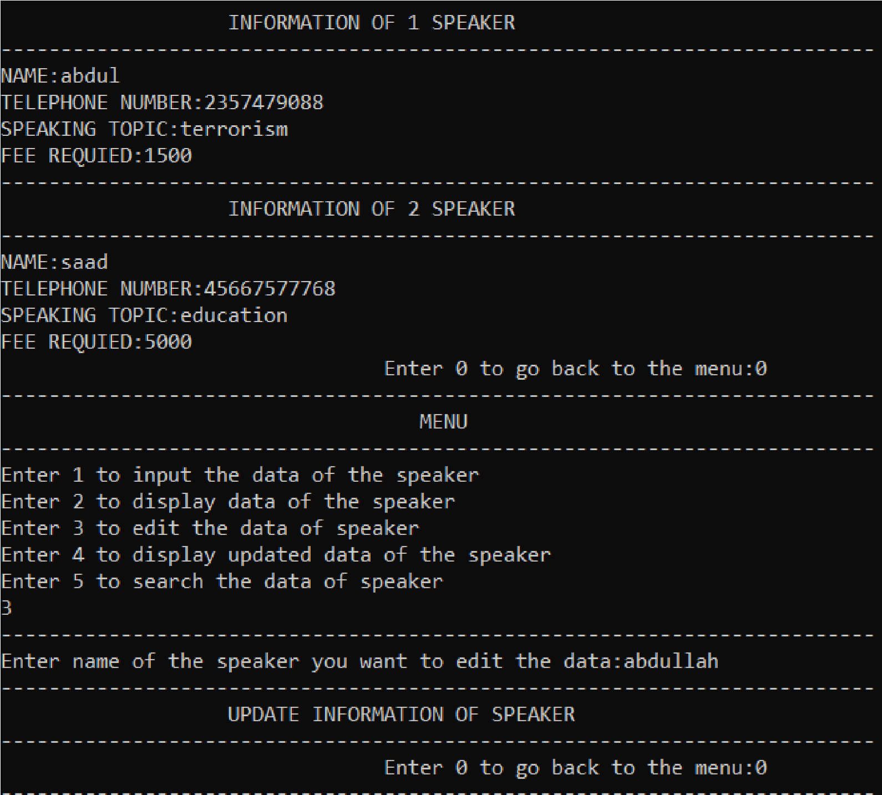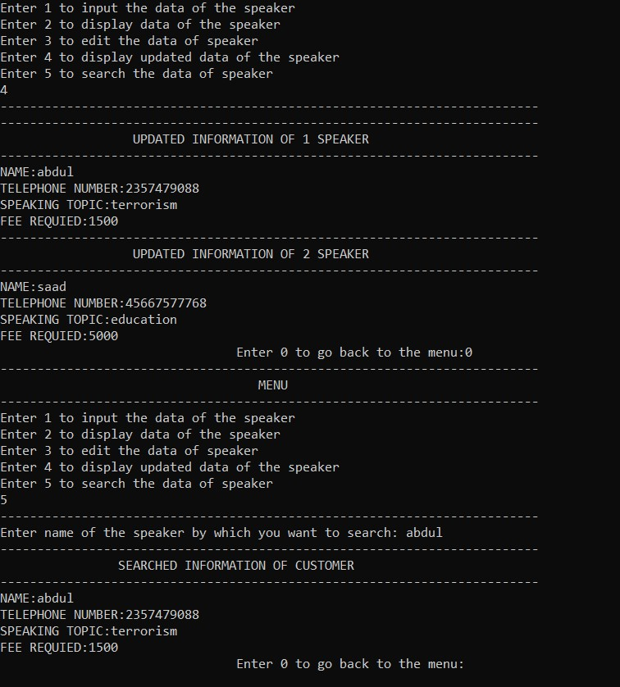

**Programme:11**

#include<iostream> using namespace std; struct monthly_budget

{

float housing, utlities, household_expenses, transpotation, food, medical, insurance, entertainment,

clothing,miscellaneous;

};

void input(monthly_budget a);

void report(monthly_budget x, monthly_budget y); int main()

{

monthly_budget a; monthly_budget x{};

a.housing = 5.00;

a.utlities = 150;

a.household_expenses = 65.0;

a.transpotation = 50.0;

a.food = 250.0;

a.medical = 30.0;

a.insurance = 100.0;

a.entertainment = 150.0;

a.clothing = 75.0;

a.miscellaneous = 50.0;

input(x);

report(x, a);

}

void input(monthly_budget a)

{

cout << "Enter the monthly housing expense:"; cin >> a.housing;

cout << "Enter the monthly utlities expense:"; cin >> a.utlities;

cout << "Enter the monthly household expenses expense:"; cin >> a.household_expenses;

cout << "Enter the monthly transpotation expense:"; cin >> a.transpotation;

cout << "Enter the monthly food expense:";

cin >> a.food;

cout << "Enter the monthly medical expense:"; cin >> a.medical;

cout << "Enter the monthly insurance expense:"; cin >> a.insurance;

cout << "Enter the monthly entertainment expense:"; cin >> a.entertainment;

cout << "Enter the monthly clothing expense:"; cin >> a.clothing;

cout << "Enter the monthly miscellaneous expense:"; cin >> a.miscellaneous;

}

void report(monthly_budget x,monthly_budget y)

{

float z;

z = y.housing - x.housing; if (y.housing > x.housing)

{

cout << "OVER BUDGET FOR HOUSING" << endl; cout << z << endl;

}

else

{

cout << "UNDER AMOUNT" << endl; cout << z << endl;

}

z = y.utlities - x.utlities; if (y.utlities > x.utlities)

{

cout << "OVER BUDGET FOR UTLITIES" << endl; cout << z << endl;

}

else

{

cout << "UNDER AMOUNT" << endl;

cout << z << endl;

}

z = y.household_expenses - x.household_expenses; if (y.household_expenses > x.household_expenses)

{

cout << "OVER BUDGET FOR HOUSEHOLD EXPENSE" << endl; cout << z << endl;

}

else

{

cout << "UNDER AMOUNT" << endl; cout << z << endl;

}

z = y.transpotation - x.transpotation; if (y.transpotation > x.transpotation)

{

cout << "OVER BUDGET FOR TRANSPOTATION" << endl; cout << z << endl;

}

else

{

cout << "UNDER AMOUNT" << endl; cout << z << endl;

}

z = y.medical - x.medical;

if (y.medical > x.medical)

{

cout << "OVER BUDGET FOR MEDICAL" << endl; cout << z << endl;

}

else

{

cout << "UNDER AMOUNT" << endl; cout << z << endl;

}

z = y.food - x.food; if (y.food > x.food)

{

cout << "OVER BUDGET FOR FOOD" << endl; cout << z << endl;

}

else

{

cout << "UNDER AMOUNT" << endl; cout << z << endl;

}

z = y.insurance - x.insurance; if (y.insurance > x.insurance)

{

cout << "OVER BUDGET FOR INSURANCE" << endl; cout << z << endl;

}

else

{

cout << "UNDER AMOUNT" << endl;

}

z = y.entertainment - x.entertainment; if (y.entertainment > x.entertainment)

{

cout << "OVER BUDGET FOR ENTERTAINMENT" << endl; cout << z << endl;

}

else

{

cout << "UNDER AMOUNT" << endl; cout << z << endl;

}

z = y.clothing - x.clothing; if (y.clothing > x.clothing)

{

cout << "OVER BUDGET FOR CLOTHING" << endl; cout << z << endl;

}

else

{

cout << "UNDER AMOUNT" << endl;

cout << z << endl;

}

z = y.miscellaneous - x.miscellaneous; if (y.miscellaneous > x.miscellaneous)

{

cout << "OVER BUDGET FOR MISCELLANEOUS" << endl; cout << z << endl;

}

else

{

cout << "UNDER AMOUNT" << endl; cout << z << endl;

}

}

**Output:**

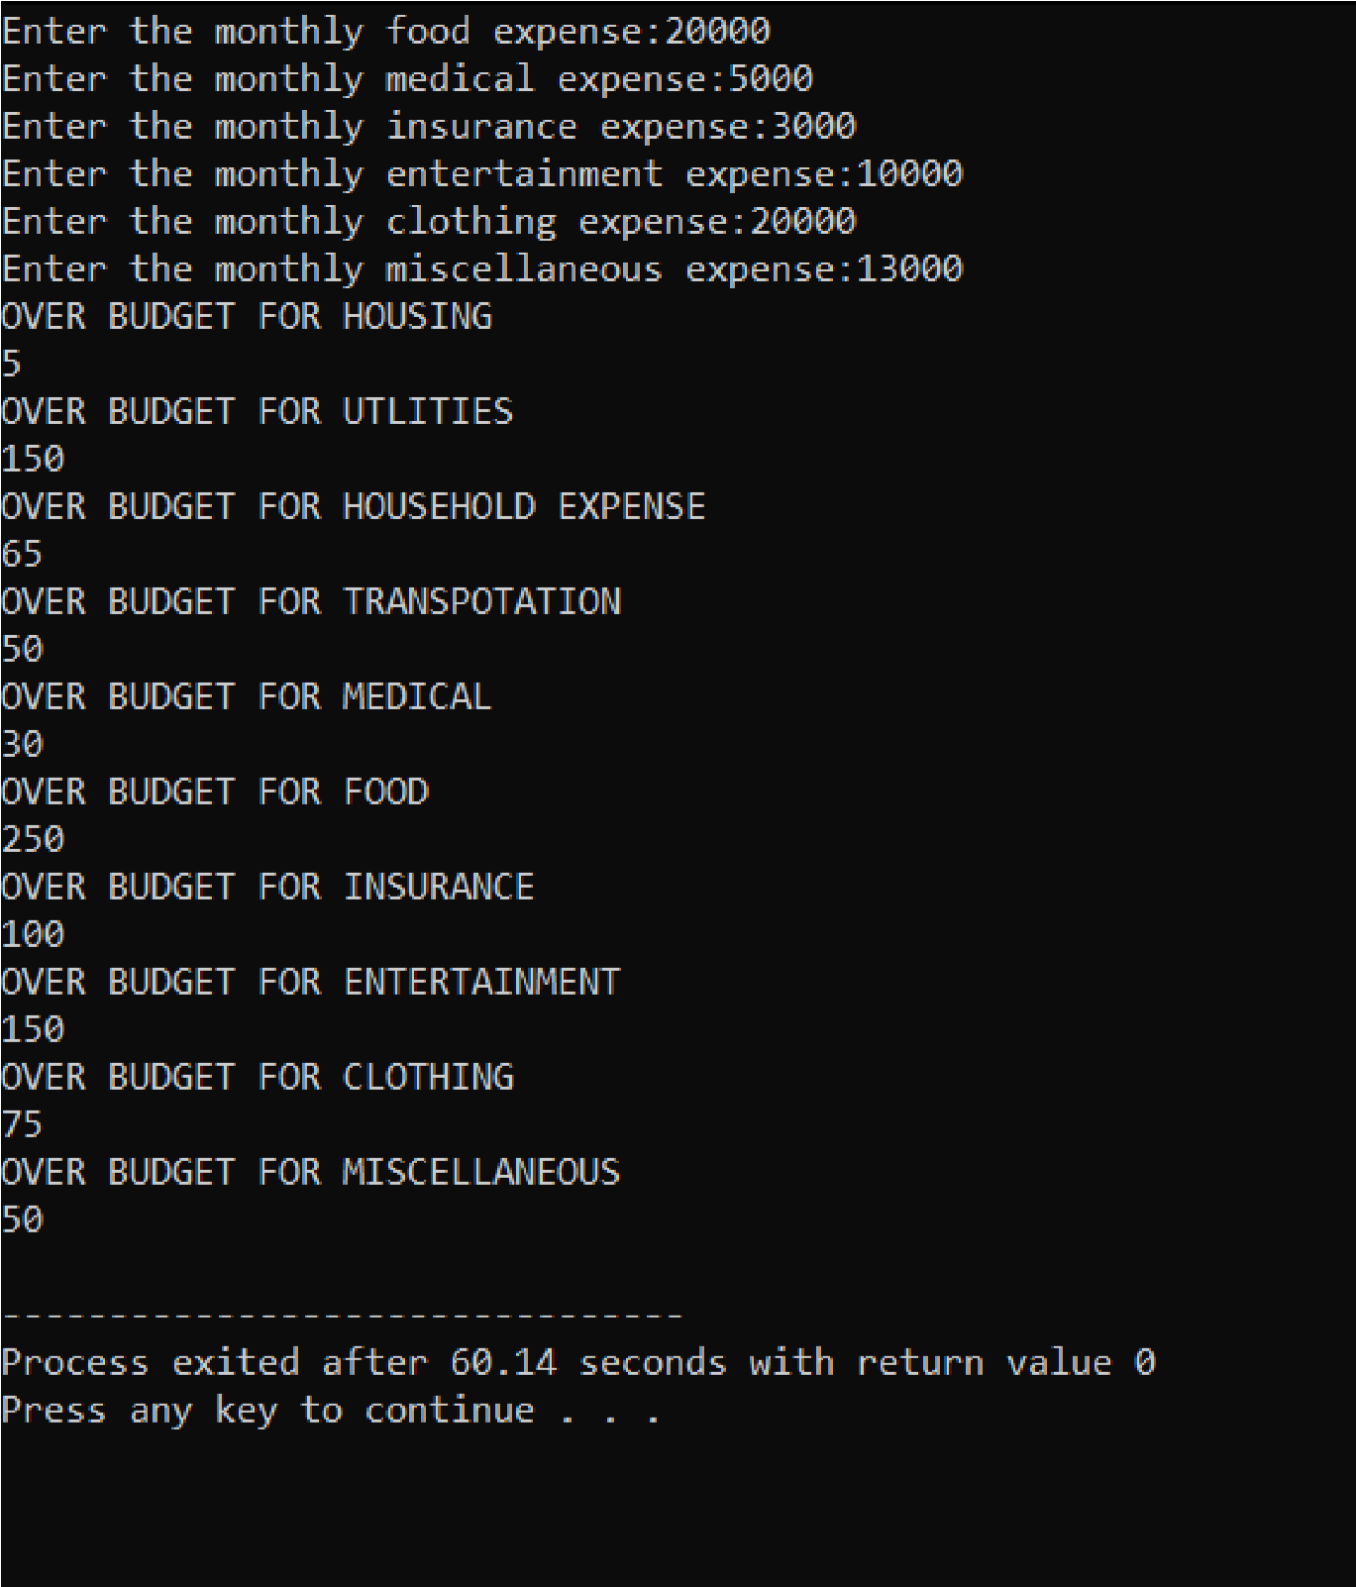

**Programme :12**

#include <iostream>

#include <cstring>

#include <cstdlib>

#include <iomanip>

using namespace std;

const int MAX_NAME_LENGTH = 50;

struct Member { char name[MAX_NAME_LENGTH];

int id; int num; int* tests; float average; char grade;

};

int main() { int numStudents; cout << "Enter the number of students: "; cin >> numStudents;

Member* students = new Member[numStudents]; for (int i = 0; i < numStudents; i++) { cout << "Enter the name of student " << i+1 << ": "; cout << "Enter the ID number of student " << i+1 << ": "; cin >> students[i].id;

cout << "Enter the number of tests for student " << i+1 << ": "; cin >> students[i].num; students[i].tests = new int[students[i].num];

cout << "Enter the test scores for student " << i+1 << ": "; int sum = 0; for (int j = 0; j < students[i].num; j++) { cin >> students[i].tests[j]; sum += students[i].tests[j];

}

students[i].average = (float)sum / students[i].num;

if (students[i].average >= 91) { students[i].grade = 'A';

} else if (students[i].average >= 81) { students[i].grade = 'B';

} else if (students[i].average >= 71) { students[i].grade = 'C';

} else if (students[i].average >= 61) {

} else { students[i].grade = 'E';

}

}

cout << endl << "Name" << setw(20) << "ID" << setw(20) << "Average" << setw(20) <<

"Grade" << endl; for (int i = 0; i < numStudents; i++) { cout << students[i].name << setw(20) << students[i].id << setw(20) << setprecision(2) << fixed << students[i].average << setw(20) << students[i].grade << endl;

}

// Deallocate memory for (int i = 0; i < numStudents; i++) { delete[] students[i].tests;

} delete[] students; return 0;

}

**Output:**

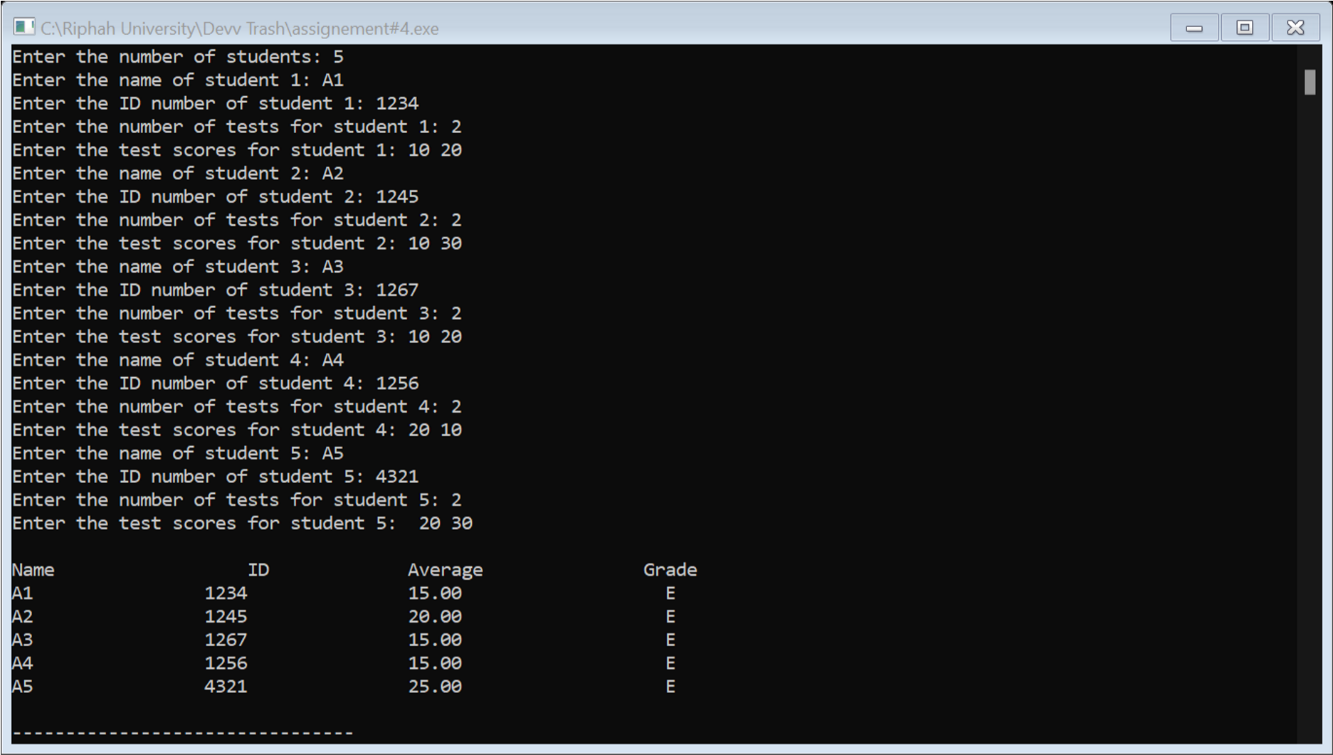

**Programme:13**

#include <iostream>

using namespace std;

struct HourlyPaidWorker {

int hoursWorked;

double hourlyRate;

};

struct SalariedWorker {

double salary;

double bonus;

};

union Worker {

HourlyPaidWorker hourlyWorker;

SalariedWorker salariedWorker;

};

int main() {

Worker worker;

cout << "Are you calculating pay for an hourly paid worker or a salaried worker? (Enter 'hourly' or 'salaried'): ";

string workerType;

cin >> workerType;

if (workerType == "hourly") {

cout << "Enter number of hours worked: ";

cin >> worker.hourlyWorker.hoursWorked;

while (worker.hourlyWorker.hoursWorked < 0 || worker.hourlyWorker.hoursWorked > 80) {

cout << "Invalid input. Enter a number between 0 and 80: ";

cin >> worker.hourlyWorker.hoursWorked;

}

cout << "Enter hourly rate: ";

cin >> worker.hourlyWorker.hourlyRate;

while (worker.hourlyWorker.hourlyRate < 0) {

cout << "Invalid input. Enter a positive number: ";

cin >> worker.hourlyWorker.hourlyRate;

}

double pay = worker.hourlyWorker.hoursWorked * worker.hourlyWorker.hourlyRate;

cout << "Pay for hourly paid worker: $" << pay << endl;

}

else if (workerType == "salaried") {

cout << "Enter salary: ";

cin >> worker.salariedWorker.salary;

while (worker.salariedWorker.salary < 0) {

cout << "Invalid input. Enter a positive number: ";

cin >> worker.salariedWorker.salary;

}

cout << "Enter bonus: ";

cin >> worker.salariedWorker.bonus;

while (worker.salariedWorker.bonus < 0) {

cout << "Invalid input. Enter a positive number: ";

cin >> worker.salariedWorker.bonus;

}

}

}

**OUTPUT**

